**Java Individual Project Description**

* Nitesh Bhusal

CIS 4660

Driving License Appointment System

**System Description**: The system will be intended to be used by users to register and pay for their driving test.

3 Tiered applications with JSP web-pages for users to enter personal information, book a test date, proceed to payment and receive a confirmation; database for storing user information; and a business logic object that acts as a mediator to get/set pages, store/retrieve from the database, whilst performing business logic, supported with a model.

Preferred IDE: Eclipse EE Mars 4.5.0

Preferred Database: MySql Community

Required/supporting External Library: MySql Connector for Java

Database: Original State

**Overview:**

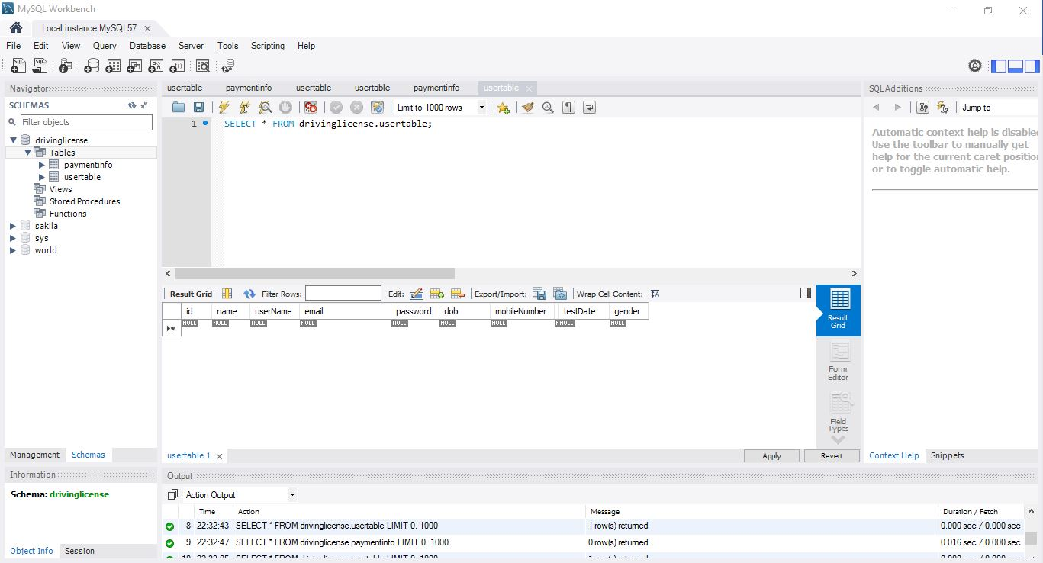

**Description**: Above, the overview of *drivinglicense* (the DB) with tree view.

Table Schema:

**usertable** Table

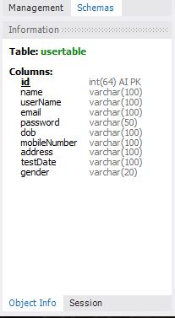

**Description**: Above, schema for usertable table.

**paymentinfo** Table

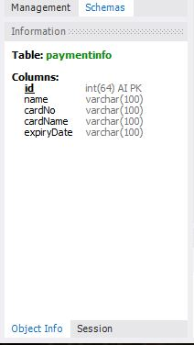

**Description**: Above, schema for *paymentinfo* table.

Tables: Original View

**usertable** Table

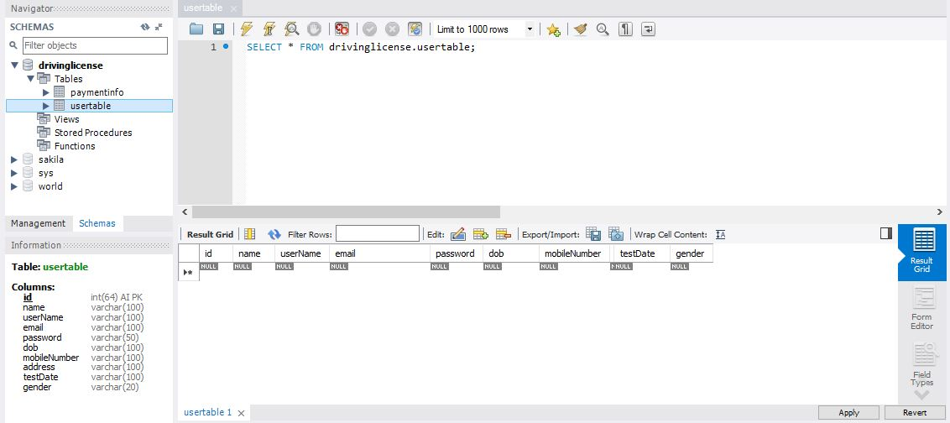

**Description:** *usertable* table with no row data

**paymentinfo** Table

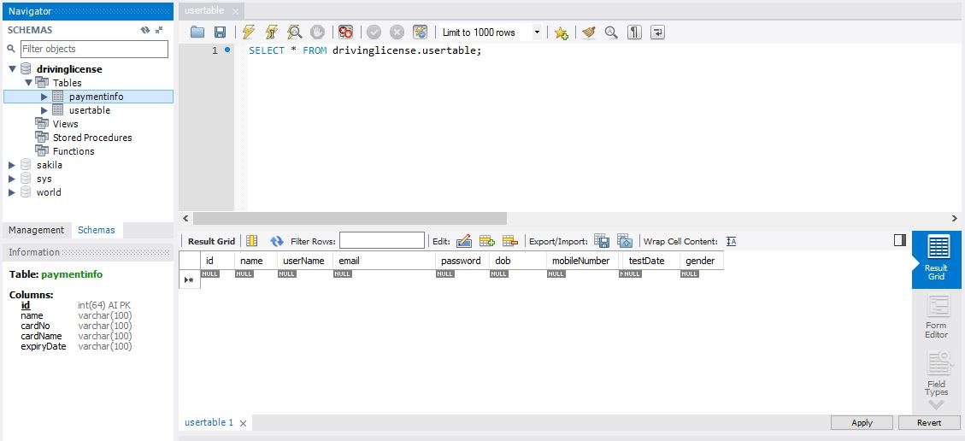

**Description**: *paymentinfo* table with no row data

JSP 1: **register.jsp**

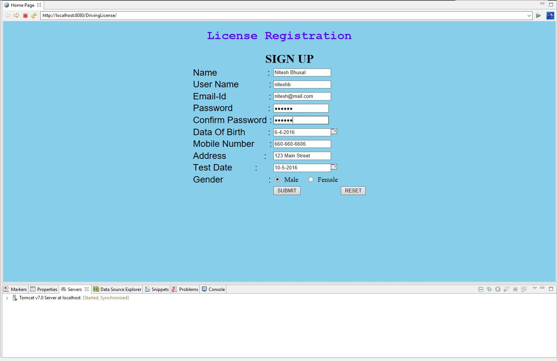

**Description**: This is the initial page user lands in after the project is run. User then fill the form, making relevant selection namely, Birth Date, Test Date and Gender. Later, the “SUBMIT” button is clicked, which inserts the values into the *usertable* table (refer next picture), then simultaneously redirects the user to the payment section (payment.jsp) of the web-app.

Database State: After user proceeds through register.jsp to payment.jsp

**Description**: The values inserted only into the *usertable* table, while the *paymentinfo* table is empty until the user is still in the payment page (payment.jsp).

**usertable** Table

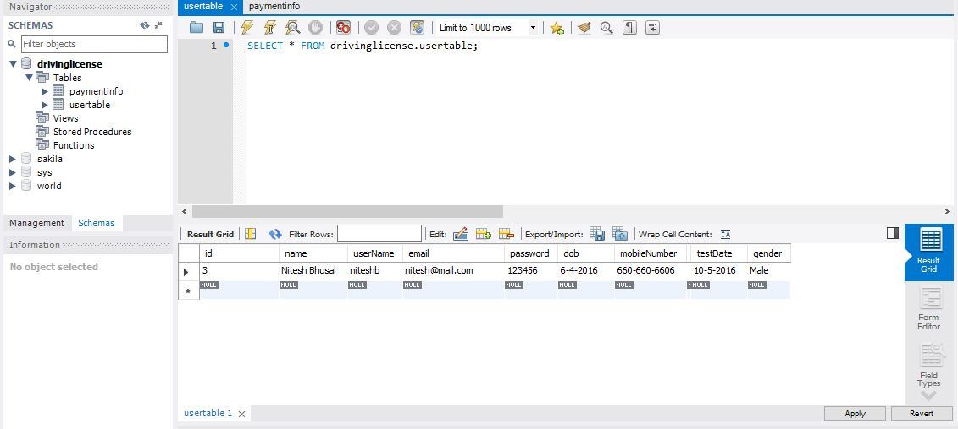

**paymentinfo** Table

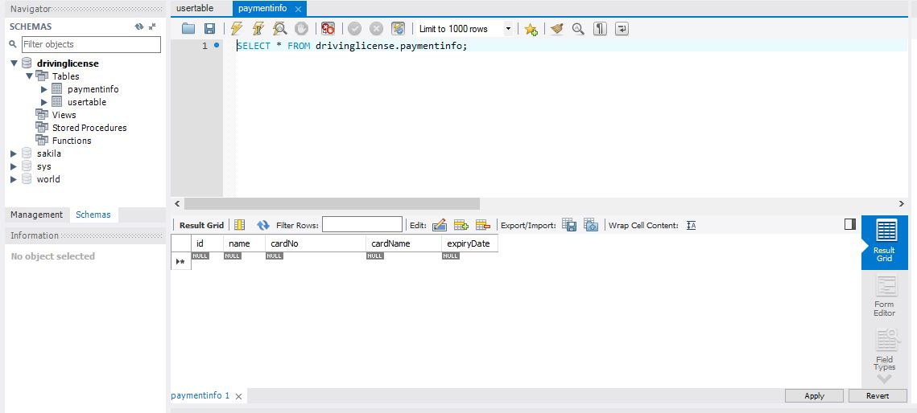

JSP 2: **payment.jsp**

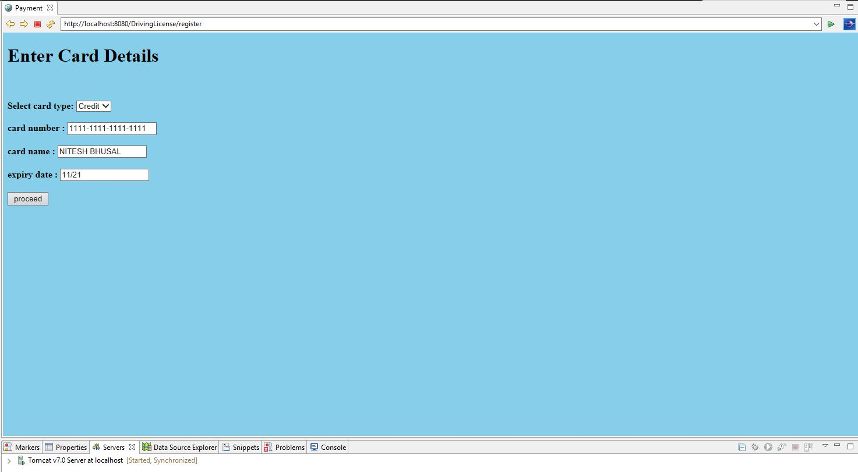

**Description:** User then fills in their respective card details details then clicks on the “proceed” button. Which then triggers an insert of the filled values into the *payment* table (refer following two pictures), then redirects the user to the confirmation page (success.jsp).

Database State: After user proceeds from payment.jsp to register.jsp to success.jsp

**Description:** At this state, the user has filled their registration information and should be on the payment details section (payment.jsp), which means *usertable* table has a row inserted, while *payment* table is yet to.

**usertable** Table



**paymentinfo** Table



JSP 3: **success.jsp**

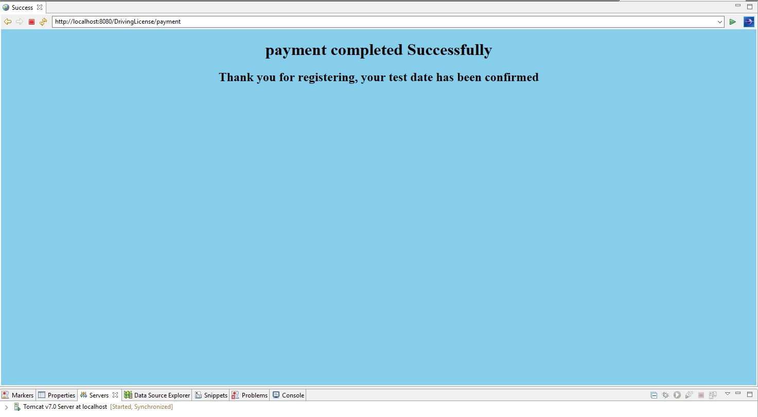

**Description:** The user reaches this page following from the payment details screen, at this stage both the tables have corresponding details filled (refer following pictures), and the user should have been registered.

Database State: After user proceeds from payment.jsp to register.jsp to success.jsp

**usertable** Table



**paymentinfo** Table

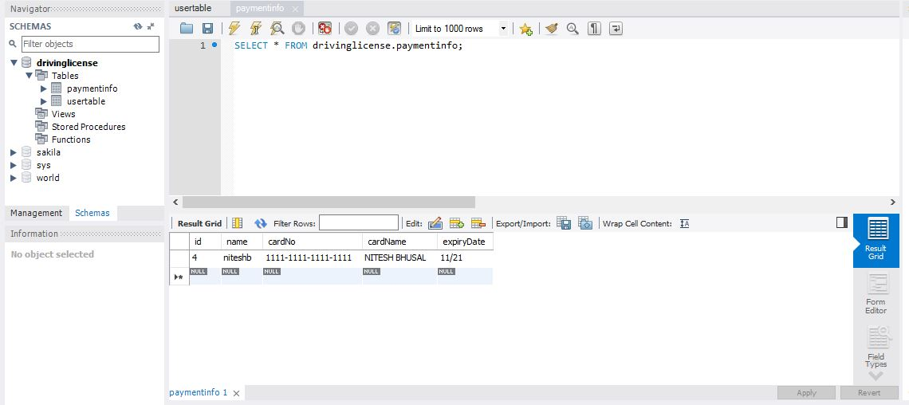

END OF DOCUMENT